Receiver

📥 What Is a Receiver?
# Source: AI Source: Provided by: [Data Path: Persons Table -> ID Column: 1, Name_En Column: Motasem Essam] -> From: [ChatGPT] on [1/23/2026]
A receiver is an electronic device or circuit that captures incoming signals (usually radio waves) and converts them into usable information, like sound, video, or data.
In simple terms:
A receiver is the "listener" that picks up wireless signals and turns them back into messages we can hear, see, or use.

📡 What Does a Receiver Do?
# Source: AI Source: Provided by: [Data Path: Persons Table -> ID Column: 1, Name_En Column: Motasem Essam] -> From: [ChatGPT] on [1/23/2026]
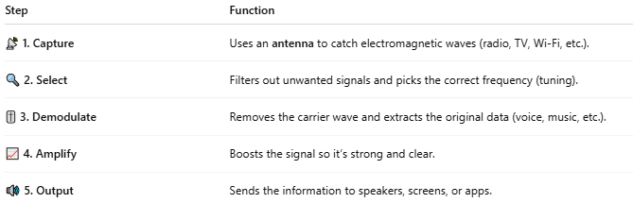

Step | Function
📡 1. Capture | Uses an antenna to catch electromagnetic waves (radio, TV, Wi-Fi, etc.).
🔍 2. Select | Filters out unwanted signals and picks the correct frequency (tuning).
🎚️ 3. Demodulate | Removes the carrier wave and extracts the original data (voice, music, etc.).
📈 4. Amplify | Boosts the signal so it’s strong and clear.
🔊 5. Output | Sends the information to speakers, screens, or apps.

📺 Examples of Receivers:
# Source: AI Source: Provided by: [Data Path: Persons Table -> ID Column: 1, Name_En Column: Motasem Essam] -> From: [ChatGPT] on [1/23/2026]
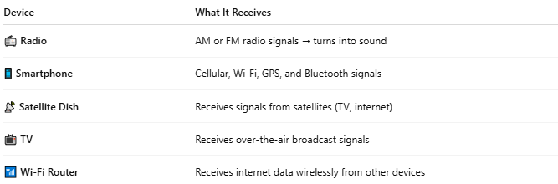

Device | What It Receives
📻 Radio | AM or FM radio signals → turns into sound
📱 Smartphone | Cellular, Wi-Fi, GPS, and Bluetooth signals
📡 Satellite Dish | Receives signals from satellites (TV, internet)
📺 TV | Receives over-the-air broadcast signals
📶 Wi-Fi Router | Receives internet data wirelessly from other devices

🔁 Receiver vs Transmitter:
# Source: AI Source: Provided by: [Data Path: Persons Table -> ID Column: 1, Name_En Column: Motasem Essam] -> From: [ChatGPT] on [1/23/2026]
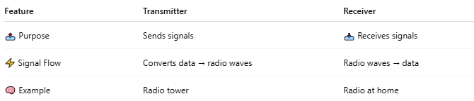

Feature | Transmitter | Receiver
📤 Purpose | Sends signals | 📥 Receives signals
⚡ Signal Flow | Converts data → radio waves | Radio waves → data
🧠 Example | Radio tower | Radio at home

Transmitter and Receiver work together
# Source: AI Source: Provided by: [Data Path: Persons Table -> ID Column: 1, Name_En Column: Motasem Essam] -> From: [ChatGPT] on [1/23/2026]
Absolutely! Here's a simple overview of how a transmitter and receiver work together in a communication system:

📡 Basic Communication Model
# Source: AI Source: Provided by: [Data Path: Persons Table -> ID Column: 1, Name_En Column: Motasem Essam] -> From: [ChatGPT] on [1/23/2026]

[Sender / Transmitter] ---> [Transmission Medium] ---> [Receiver]

🔧 Step-by-Step Breakdown
# Source: AI Source: Provided by: [Data Path: Persons Table -> ID Column: 1, Name_En Column: Motasem Essam] -> From: [ChatGPT] on [1/23/2026]
- 🧠 Information Source
  - The sender has data to transmit (e.g., text, voice, video).
- 📤 Transmitter
  - Converts the data into signals (electrical, radio, optical).
  - Adds encoding/modulation so it can travel over the medium.
- 🌐 Transmission Medium
  - The path the signal travels through (e.g., cables, air, fiber optics).
  - Could introduce noise or interference.
- 📥 Receiver
  - Captures the incoming signal.
  - Decodes and demodulates it back into usable data.
- 🧑‍💻 Destination
  - The final user or system that uses the information (e.g., phone, computer, application).

📶 Real-World Example: Sending a Voice Message Over Wi-Fi
# Source: AI Source: Provided by: [Data Path: Persons Table -> ID Column: 1, Name_En Column: Motasem Essam] -> From: [ChatGPT] on [1/23/2026]
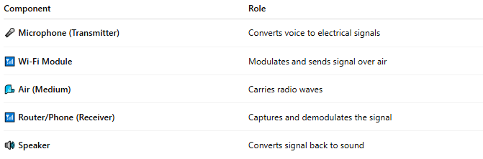

Component | Role
🎤 Microphone (Transmitter) | Converts voice to electrical signals
📶 Wi-Fi Module | Modulates and sends signal over air
🌬 Air (Medium) | Carries radio waves
📶 Router/Phone (Receiver) | Captures and demodulates the signal
🔊 Speaker | Converts signal back to sound

📦 In Networking Terms:
# Source: AI Source: Provided by: [Data Path: Persons Table -> ID Column: 1, Name_En Column: Motasem Essam] -> From: [ChatGPT] on [1/23/2026]
- Transmitter = Your device’s network interface card (NIC)
- Receiver = The NIC on the other end
- Medium = Ethernet cable, fiber optic, or radio (Wi-Fi)

📖 Summary:
# Source: AI Source: Provided by: [Data Path: Persons Table -> ID Column: 1, Name_En Column: Motasem Essam] -> From: [ChatGPT] on [1/23/2026]
A receiver is a vital part of any wireless system. It receives radio waves, filters and decodes the signal, and outputs the original message — whether it's a phone call, a YouTube video, or your location on a map.

